Name:
Date:

Map Projections

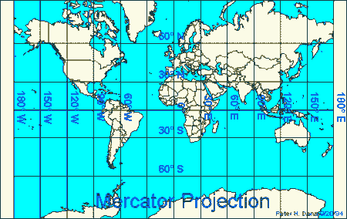
If you tried to flatten a tennis ball, the sides would split and the shape would change. The same thing would happen if you tried to flatten a world map onto a piece of paper. It is impossible to create a two-dimensional map of the three-dimensional earth without stretching some places. Mapmakers call this stretching distortion. A globe can show size, shape, distance, and direction accurately, but since a flat map cannot be three-dimensional, we have to use map projections. A map projection is a way to show a drawing of the earth on a flat surface. All flat maps have distortion, so we use different map projections to meet different needs.
In 1569, Gerardus Mercator created a map where parallels and meridians cross at right angles. The Mercator Projection is excellent for navigation because it shows direction clearly. The Mercator Projection, however, has a great amount of distortion. In order to get the parallels and meridians to cross at right angles, Mercator stretched the areas further away from the poles and squeezed the areas closer to the equator.
An equal area map displays the shapes and sizes of things more accurately than a Mercator Projection. The Mollweide Projection is one of several equal area maps. The Mollweide Projection sacrifices accuracy of angle and shape in favor of accurate proportions in area. Compare Greenland and Africa on the two projections. Africa is actually fourteen times larger than Greenland, but on a Mercator Projection, the two regions are about the same size.
Many modern mapmakers use complicated mathematical formulas that combine the advantages of the Mercator Projection and an equal area map. The border of the western United States and Canada is the longest straight border in the world. On some map projections depict the border as a straight line; on other map projections you will notice a slight bend due to the curvature of the earth.

Fill in the Blanks

The earth is a s__________, and it is i__p__s__ib__e to create a f______ map of a *s__h__r__c__l object without d__________________. The Mercator P__________________ is excellent for n__________________ because it shows d________________ clearly. P_______________ and m________________ cross at r________ angles on a M______________ Projection, so the maps have a great deal of d__________________. An e________ area m____ displays s__________ and s________ more a___________________ than a M______________ Projection, but on this type of map, p________________ and m_________________ do not c__________ at right a__________.

Name:
Date:

Answer in complete sentences
*1. Explain why it is impossible to display a map of the world on a flat surface without stretching or shrinking some places.
2. What is a map projection?
*3. What part of the earth is “squeezed” into a smaller area by the Mercator Projection? Why?

Absolute and Relative Locations

If someone were to ask where your school is, you might answer that the school is at 1901 North Australian Avenue in West Palm Beach, Florida. It probably wouldn’t be very helpful, but you could also truthfully answer that our school is precisely at 38.8977° N, 77.0366° W. These are examples of absolute locations.
It is often more helpful to describe your relative location. For example, the White House is a bit les than a mile northeast of the Lincoln Memorial. We could also say that the White House is across the street from Lafayette Park. Both absolute and relative location are useful tools for geographers, and we will use both throughout our study.

Answer in complete sentences
*4. Describe the absolute location of where you are completing this assignment.
*5. Describe the absolute location of where you are completing this assignment.

