Name: |  |  | 
Date:

ALEXANDRIA

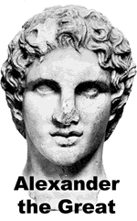
In 332bce, a Greek military leader named Alexander the Great led an army into Egypt. For nearly two centuries at that time, the ancient land had been under the control of Persia, a powerful empire in western Asia. As Alexander’s army defeated the Persians, the Egyptian people welcomed Alexander. Some Egyptians even worshipped the Greek general as a pharaoh.
Alexander soon left Egypt to continue his conquests, but before leaving, he established a new capital named for himself on a port city on the Mediterranean Sea. This city called Alexandria became a center of trade between Egypt and other cities in a growing empire.
The Greek rulers who succeeded Alexander constructed the greatest library of the ancient world in Alexander’s capital. The Royal Library at Alexandria collected books from all over the known world and attempted to gather all of the world’s knowledge in one place.
Because books had to be copied by hand, they were very rare before Johann Gutenberg invented the printing press about 1450ce. Legends say that books were seized from ships sailing into Alexandria’s port. Scribes at the library then copied the books manually. The library would keep the original volumes and returned only the copies to their owners.
The Royal Library at Alexandria was housed in many buildings, but many of those buildings were destroyed over the next nine centuries. The final destruction of the library appears to have occurred in the seventh century of the Common Era.
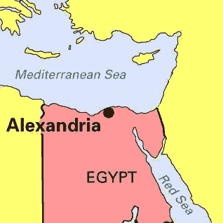
A modern library, the Bibliotheca Alexandrina, was constructed in Alexandria in 2002. Similar to the ancient library’s mission of pulling together all knowledge, today’s version houses a copy of the Internet Archive, a vast computer collection that attempts to keep a record of nearly anything ever posted on the Internet. You can access the Internet Archive and see backed-up copies of what websites looked like in the past at www.archive.org.

Fill in the Blanks
A Greek warrior named A__e__a__d__r rescued Egypt from P__r__i__n rule 332bce. Alexander established a new c__p__t__l in a city he called A__e__a__d__ia, where his successors later constructed the greatest l__b__a__y of the ancient world.
The Royal Library at Alexandria attempted to gather all of the world’s k__o__l__dge in one place. Legends say books were *c__n__i__c__t__d from ships sailing into Alexandria’s p________. The library lasted almost a *m__l__e__n__um before it was destroyed. A modern library constructed in A__e__a__d__ia in 2002 houses a collection of nearly every In__e__n__t website ever created.

Answer in complete sentences
1. List two civilizations that conquered all or part of ancient Egypt.
*2. Irony can be defined as an occurrence that is the opposite of what you would expect to happen. Why is it ironic that we do not know why the Royal Library at Alexandria was destroyed?

