THE GIFT OF THE NILE

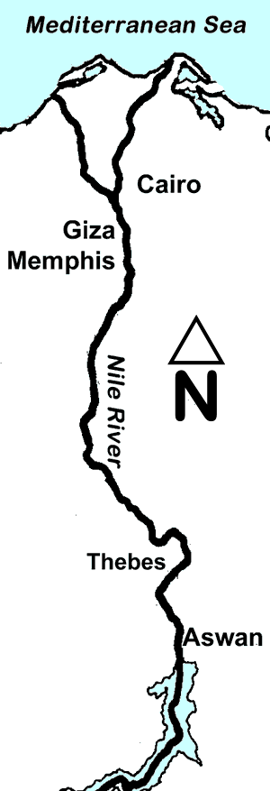
Like a giant snake, the Nile River slithers through some of the driest desert land on earth to create a narrow green valley. The ancient Greeks called this land Egypt. For more than five thousand years, famous and often mysterious civilizations thrived along the banks of the Nile. About 450BC, a Greek historian named Herodotus called Egypt the “Gift of the Nile” because the Egyptian civilization depended on the resources of the great river.
Every spring, the snow on the mountains of East Africa melted, sending a torrent of water that overflowed the banks of the Nile and flooded the river valley. The rushing river picked up bits of soil and plant life called silt. As the annual flood receded, a strip of black topsoil emerged every year along the banks of the Nile. The silt was rich in nutrients, and it provided the people of Egypt with two or three crops every year.
The Nile made it possible for the people of ancient Egypt to form the first nation in history. A nation may refer to a community of people who share a common language, culture, ethnic background or history. The land beyond the Nile River Valley is the Sahara Desert. A desert is land that receives less than ten inches of rain in a typical year. Since it is nearly impossible to grow much food in the desert, few people lived far from the banks of the Nile. Giant boulders blocked the Nile and formed a natural border at the southern Egyptian city of Aswan. The Nile flows into the vast Mediterranean Sea, which formed Egypt’s border to the north. Egypt’s isolation led to its unification. People living along the banks of the Nile River spoke the same language and worshipped many of the same gods more than five thousand years ago.
The Nile no longer overflows its banks because modern Egyptians built a huge dam in Aswan. Since 1970, the Aswan High Dam has held back the water that annually flooded the banks of the Nile River. The dam also provides a reliable flow of water for Egyptian farmers in the dry season. The people of Egypt are now able to convert the predictable flow of the Nile into electricity. The Aswan High Dam initially provided electricity to more than half of the villages along the Nile. The population of Egypt has grown since then, but the Aswan High Dam still contributes about fifteen percent of Egypt’s electricity. Unlike oil, the flowing water is renewable, which means that the river will not run out. Ancient and modern civilizations have relied on the mighty river, proving that Egypt truly is the “Gift of the Nile.”

Map Skills

1. The Nile River Delta is a rich farming area where the Nile spreads out before draining into the Mediterranean Sea. The Delta is shaped like a triangle, which reminded the Greeks of a letter in their alphabet called delta. () Please write the word DELTA in the correct location.

2. We know the Nile flows into the Mediterranean Sea. In what direction does the Nile flow along most of its course? Circle the correct answer: NORTH SOUTH EAST WEST

Fill in the Blanks
An ancient Greek historian named H__r__d__t__s called Egypt the “G______ of the N______” because the E__y__t__an people have depended on the great r__v__r for more than five t__o__s__nd years. Until 1970, the Nile would o__e__f__ow its b__n__s every year. When the flood *s__b__i__ed, it left behind bits of s______ and p__a__t__i__e called silt. The silt was rich in n__t__i__n__s that allowed the people of ancient Egypt to grow c__o__s on land that would have otherwise have been dry d__________. The Nile no longer overflows its bank because Egypt constructed a huge dam in A__w__n. While the Nile no longer provides t__p__o__l, the p__e__i__t__b__e flow of the r__v__r supplies the Egyptian people with a r__n__w__b__e source of e__e__t__i__i__y.

Answer in Complete Sentences
3. A simile is a figure of speech that compares two different things. Copy the sentence in the passage that contains a simile.

4. What is silt?

*5. Write a paragraph that explains how ancient Egypt was isolated from other cultures by natural borders. Your paragraph must have a topic sentence, a least two support sentences and a conclusion sentence that restates but does not repeat the topic sentence.

*6. Explain why the Nile River no longer overflows its banks.

