THE ROSETTA STONE

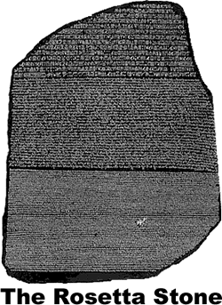
The writing of the ancient Egyptians was a great mystery until the discovery of the Rosetta Stone. In 1799, French soldiers were building a fort near the Egyptian village of Rosetta. The soldiers unearthed a dark grey-pinkish granite stone that stood about four feet tall and 2½ feet wide. The Rosetta Stone was inscribed with three languages. One language was Greek, but the others were forms of Egyptian writing that were unreadable at that time. The Greek writing described a law written in 196bce. Scholars decided the Greek writing might give clues to the meaning of the Egyptian symbols.
The British seized Egypt in 1801 and transported the Rosetta Stone to the British Museum. Scholars carefully studied the scripts, but their work proceeded slowly because parts of the stone had crumbled.

EGYPT AFTER THE PHARAOHS
At the time the French soldiers found the Rosetta Stone in 1799, much of what we know about the history of ancient Egypt was a mystery. The Egyptians were very reluctant to accept new ideas. They looked to the past for protection from the gods who they believed created their special land.
The era of the pharaohs faded as Egypt became easy prey for invading armies with more advanced weapons. Armies from Persia, Assyria, Kush, and Nubia dominated Egypt until a Greek military leader conquered the ancient kingdom in 332bce.
Alexander the Great created the largest military empire the world had ever known, but he died suddenly in 323bce. Alexander’s empire was divided among his top generals. Ptolemy established a Greek dynasty that controlled Egypt for nearly three hundred years. The Ptolemaic dynasty fell to the Romans when Caesar Augustus defeated Cleopatra, the last queen of Egypt in 44bce.
A Turkish army seized Egypt in 1517 and made the ancient and mysterious land part of the Ottoman Empire. The French army that found the Rosetta Stone invaded Egypt in 1798, but the French fell to the British three years later. A revolt by Egyptian soldiers in 1952 forced the British out of Egypt. Since that time, Egypt has been an independent nation.
In time, the scholars concluded that the law was written in hieroglyphics and demotic scripts. Hieroglyphics was the sacred writing of ancient Egypt and was known only by the most learned priests. Demotic was a cursive script that the Egyptians used for less formal writing. Demotic writing shared some similarities with Greek.
In 1822, a French linguist named Jean Champollion matched several characters from the three texts and slowly deciphered an alphabet of hieroglyphics. Champollion concluded that hieroglyphics had originally been pictographs, but they stood for sounds in later times. Using Champollion’s key, the mysterious hieroglyphic text became readable. Within a few years, scholars were able to find the explanation for the pyramids and many of the other mysteries of ancient Egypt.
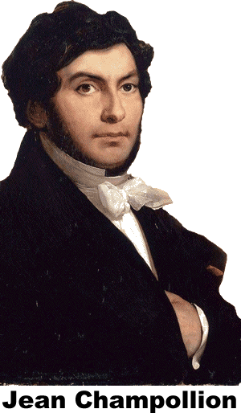
In 2003, Egypt formally requested that the British return the Rosetta Stone to its original home. The British Museum and other leading world museums issued a joint statement that rejected Egypt’s request. The statement explained that ancient artifacts such as the Rosetta Stone belong not to their home nation but to all of humanity.

Fill in the Blanks
Much of the history of a__c__e__t Egypt remained a great m__s__e__y until French s__l__i__rs found a g__a__i__e stone near the Egyptian city of R__s__t__a. A law from 196bce was i__s__r__b__d on the stone in h__e__o__l__p__i__s, demotic and G__e__k. Scholars carefully studied the writing and concluded that the same law was written in three scripts. Twenty-three years after the *d__s__o__e__y of the Rosetta Stone, French linguist Jean C__a__p__l__i__n developed an a__p__a__et of h__e__o__l__p__i__s. Later historians used Champollion’s key to study other E__y__t__an artifacts. Within a few years, historians were able to use C__a__p__l__i__n’s key to unlock many *m__s__e__i__s that had perplexed scholars for centuries.

Answer in complete sentences
*1. Who or what was the Rosetta Stone named for?
2. Explain how the Rosetta Stone made it possible for Champollion to decipher hieroglyphics.
3. Explain why the history of Egypt remained mystery for centuries?
*4. In your opinion, does the Rosetta Stone belong in the British Museum or in Egypt. Explain your reasoning.
5. What reason does the author give for the end of the age of the pharaohs?
*This is a higher order learning question. You must answer the question to the best of your ability, but any reasonable answer will be graded as correct.

