Name: |  |  | 
Date:

The Nok

In 1928, archaeologists unearthed artifacts from an amazing culture that flourished from about 500bce to 200ce. The archaeologists referred to the ancient culture as Nok, the name of a modern Nigerian village where they made their discovery.
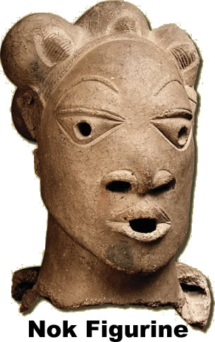
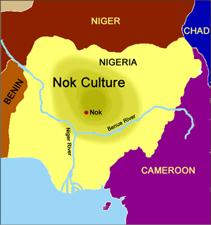
Nok artifacts included sculptures of animals and people made of terra cotta. Terra cotta is clay that has been baked in an oven. The complex Nok sculptures were probably based on woodcarvings, but any wooden artifacts would have disintegrated long ago in the humid climate of West Africa. The sophistication of the artifacts leads archaeologists to believe that the Nok civilization may have been much older than even the oldest artifact.
The Nok discovered that they were able to “smelt” iron by heating certain rocks to a high temperature. Iron is very malleable. A malleable material can be reshaped, and the Nok used iron to make weapons and plows. Most ancient cultures discovered other metals such as copper and bronze before iron, but the Nok apparently moved directly from the Stone Age to the Iron Age without having a Copper or Bronze Age.

Fill in the Blanks
.
In 1928, a__c__a__o__o__i__ts uncovered an ancient *unn__m__d civilization in the present day village of N____, Nigeria. The ancient Nok c__l__u__e apparently flourished for at least *____ years. The artifacts of the region included figurines made of t________ c________, or clay that has baked in an o______. The s________________________ of the figurines lead archaeologists to believe the N____ culture was even o__d__r than the oldest *s__u__p____re.
The a____________ Nok culture s____________ iron by h____________ rocks to a high t__m__e__a__u__e. Iron can be r__s__a__ed to make w____________ and p________. Iron can also be used for cooking and heating because it conducts heat well. The Nok apparently moved from the S________ to the I______ Age. Most cultures discovered c__________ and b__________ before iron. We don’t know if the Nok discovered the secrets of i______ on their own, or if they learned about it from another c__l__u__e.

Answer in Complete Sentences
1. The test states that the ancient Nok culture existed at the confluence of the Niger and Benue rivers. Use a dictionary to find the meaning of confluence.
2. Why do we refer to an ancient African civilization as the Nok?
*3. Why do archaeologists believe that the Nok civilization may have been much older than its oldest artifact?
*4. List five tools or weapons made from iron that would advance an ancient civilization.

