The Mauryan Empire and Ashoka

By 326bce, India was a land of many languages and cultures. Hindu rajas ruled small but often rich kingdoms. The wealth of the rajas attracted the army of Alexander the Great, a young Greek general who amassed the largest empire of his era.
Shortly after Alexander’s death in 323bce, a young soldier of a low caste named Chandragupta Maura led a rebellion that drove out the Greek invaders. By 305bce, Chandragupta’s Mauryan Empire stretched from the Bay of Bengal in eastern India across the northern portion of the subcontinent through the Hindu Kush into modern-day Afghanistan. For the first time in history, one state ruled most of the subcontinent.
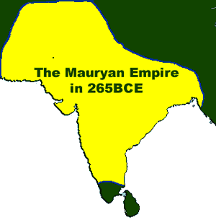
It was not the size of India, but rather its cultural diversity that made the Mauryan Empire difficult to govern. To make his empire more easily managed, Chandragupta divided it into smaller regions called provinces—each ruled by a prince and his royal family. Chandragupta’s administration of the provinces was so efficient that later conquerors of India kept parts of his system intact for centuries.
Chandragupta skillfully controlled his vast realm. He employed spies who provided him with secret reports on events in the provinces. The emperor’s servants tasted his meals for poison and the emperor slept in different beds every night.
Later in his life, Chandragupta Maura sought enlightenment by becoming a Jain. Jainism is an ancient Indian philosophy that combines elements of Hinduism and Buddhism. Jainism and Buddhism were popular with Indians who—like Chandragupta—had no status in the caste system. Legends tell us that Chandragupta eventually gave up his power and lived the last years of his life as an ascetic—a holy person who has given up all material pleasures and comforts.
Ashoka was Chandragupta’s grandson and a ferocious warrior. Upon the death of his father, Ashoka is believed to have massacred his brothers and sisters in order to seize control of the Mauryan Empire.
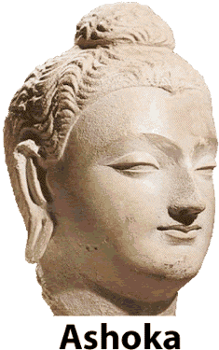
Once in power, Ashoka built an elaborate palace filled with flowers, trees, and ornaments. Deep inside the palace, however, was a torture chamber where the emperor imposed cruel punishments upon anyone who challenged his authority.
Ashoka’s army defeated the rival kingdom of Kalinga, but thousands of soldiers on each side were killed in the violent battle. Finally, as Ashoka rode out to the battlefield to rejoice in his last and greatest victory, he felt great remorse at the suffering he caused.
The emperor then had a spiritual transformation. He renounced war and became a devout Buddhist. He practiced ahimsa, the belief that one should not hurt any living thing. For the rest of his life, Ashoka refused to eat meat and banned all animal sacrifices.
Ashoka built Buddhist shrines and temples throughout Asia. The emperor sent Buddhist missionaries to foreign lands. Buddhism is no longer widely practiced on the Indian subcontinent, but it is now a major influence in China, Japan and Southeast Asia.
Ashoka spent the next forty years of his rule emphasizing human charity and respect for all living things. He ignored the caste system and insisted that all of his subjects be treated as equals. He sent engineers to build roads that encouraged people to travel and trade. The engineers also dug wells and built hospitals in poor villages.
Most of what we know about Ashoka’s rule comes from stone pillars he erected throughout his empire. The writings on some of the pillars espoused Buddhist principals, while others told the story of the Mauryan Empire. Many of the monuments have survived more than 2200 years to the present day.
The emperors who followed Ashoka were weak. After the emperor’s death, Hindu priests once again reimposed the caste system as the Mauryan Empire gradually shrunk. In 185bce, the last of the Mauryan rulers was killed, ending the dynasty that united most of the subcontinent.


Fill in the Blanks
About 323bce, C__a__d__a__u__ta Maura led a r__b__l__i__n that led to the expulsion of *f__r__i__n power in I__d__a. Chandragupta skillfully controlled the *d__v__r__e peoples of the M__u__y__n Empire by appointing p__i__c__s to g__v__rn provinces and by developing a network of s__i__s that provided the e__p__r__r with s__cr__t reports. Later in life, Ch__n__r__g__p__a gave up power and lived the last years of his life as an a__c__t__c.
Chandragupta’s *g__a__ds__n was A__ho__a, a w__r__i__r who renounced w__r after a s__i__i__u__l transformation. Ashoka became a devout B__d__hi__t who built s__r__n__s and t__m__l__s throughout A____a. Buddhism is no widely practiced on the I__d__an subcontinent, but Ashoka’s m__s__i__n__r__es spread B__d__h__st philosophy to C__i__a, Japan and S__u__h__a__t Asia.
Answer in Complete Sentences
1. Why were foreign armies interested in conquering India by 326bce?
*2. Why do you think Chandragupta Maura believed it was necessary to maintain a spy network in his empire?
3. What was the cause of Ashoka’s great spiritual conversion?
*4. Describe ahimsa using your own words.
5. Explain how Ashoka transformed Buddhism into a major world religion.
6. Why do we know more about Ashoka than most ancient rulers?
*This is a higher order learning question. Any reasonable answer will be graded as correct.

