The Early Greeks

Most of our study of ancient Greece is focused on what we call the Classical Age. The Classical Age of Greece is a two hundred year period that began about 500 years before the Common Era. During the Classical Age, the Greek poli combined to defeat the powerful Persian Empire. The Greeks of the Classical Age created art, architecture and literature that have influenced the way we live today. The Classical Age came centuries after two earlier civilizations, the Minoans and the Mycenaeans, flourished and then vanished, leaving the Greeks in a period later called the Dark Age of Ancient Greece.
The Minoan culture developed on Crete, an island southeast of the Greek mainland. The Minoans developed a system of writing and traded with other cultures that bordered the Mediterranean Sea, but the Minoan civilization mysteriously disappeared about 1450bce. There is some evidence that the fall of the Minoan civilization is related to a catastrophic volcanic eruption. The Minoans traded with the Mycenaeans, a civilization on the Greek mainland that was known for making bronze weapons and pottery. About a millennium before the Common Era, the Mycenaean culture grew weak and was conquered by invaders from the north known as Dorians.
For the next several hundred years, Greece fell into a period called the Greek Dark Age. There have been several dark ages in history. A dark age occurs when a civilization regresses, or forgets some of the things they know. Both the Minoans and the Mycenaeans had writing, but during the Greek Dark Age, few people could read and write. The Greeks of the Classical Era could not read the writing of the Minoans and the Mycenaeans, but the Classical Greeks had many legends handed down by word of mouth. These stories became the basis of what the Greeks later called their Heroic Era.
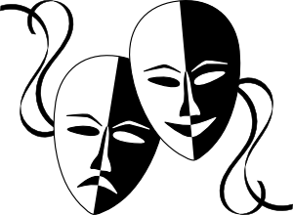
During the Greek Dark Age, poets called bards traveled to different poli. The bards told stories in the form of long poems called epics. People would often pay to hear the bards describe stories of the distant past. The bards would sing many of the epic poems while accompanied by a stringed instrument called a lyre. The musical epics were called lyric poetry.
The two oldest surviving examples of Greek literature are the Iliad and the Odyssey, epic poems that describe the Trojan War, a conflict between the Greeks and the city of Troy that the epics say was fought almost 1200 years before the Common Era. The Trojan War was fought over Helen, who according to legend was the beautiful daughter of Zeus and the wife of the king of the Greek polis of Sparta. The war began after a Trojan prince named Paris kidnapped Helen.
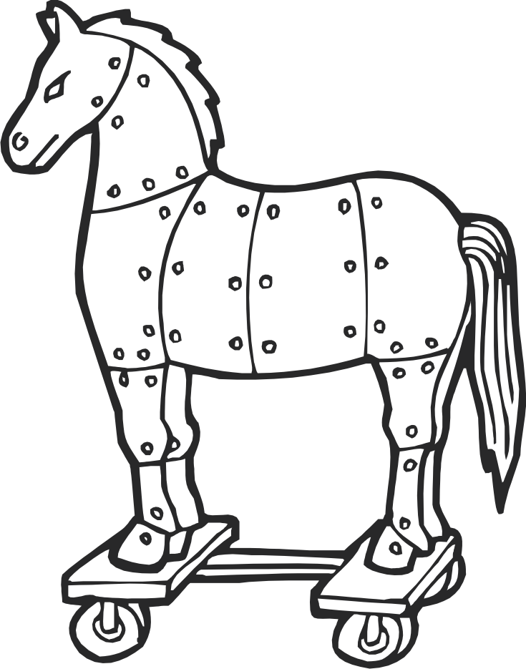
According to the Odyssey, the Trojan War ended when the Greeks pretended to give up their quest for Helen. The Greeks left a huge wooden horse as a peace offering to the Trojans. The Greek navy pretended to sail away, but they only sailed out to a hidden location. The joyous Trojans opened the city gates and pulled in the giant statue. After a great victory celebration of their defeat of the Greek army, the people of Troy slept for the night. As the Trojans slept, Greek soldiers emerged from their hiding place inside the wooden horse, opened the city gates, and began to burn the sleeping city.
Modern scholars believe the Iliad and the Odyssey are based on oral legends, but the epics are often attributed to a storyteller named Homer. The language of the Iliad and the Odyssey suggest that Homer came from the western coast of the modern nation of Turkey. Homer’s name can be translated from a word that means blind, but the vivid imagery of the Iliad and the Odyssey suggest that the author of the poems must have had sight at some point in his life.
We have only a few clues about who Homer might have been. Herodotus was a Greek writer who lived in the fifth century before the Common Era. Herodotus is often called “the Father of History.” The great historian estimated that the story of the Trojan War was at that time at least seven centuries old.
The epic stories of the bards are the foundation of Greek theater. During the Classical Age, the Greeks often performed plays at festivals honoring Dionysus. Dionysus was the Greek god of the harvest, but he was also the god of pleasure. In many Greek plays, a few actors played roles while a chorus narrated the play and offered advice to the characters. Greek tragedies were plays that described great conflicts and often ended unhappily; Greek comedies told amusing stories about Greek culture and society and generally had happy endings. The modern movies we see today are rooted in the plays of ancient Greece and the stories of the mysterious Heroic Era of ancient Greece.

Fill in the Blanks

The C__a__s__c__l Age of Ancient Greece came after the rise and fall the M__n__an and the M__c__n__e__n civilizations about a m__l__e__n__um before the Common Era. A dark age followed where few people could r______ or w________, but the stories of what was later called the H__r__ic Age were kept alive through long e________ poems performed by wandering poets called b__r__s.
The Iliad and the Odyssey are adventures often attributed to a blind storyteller named H__m__r. The Homeric epics describe the T__o__an War, a conflict won by the Greeks after the Greeks *s__c__e__ly hid soldiers in a giant statue of a h__r__e. The Trojans pulled their gift inside the city walls of Troy. That night, Greek soldiers hidden in the horse o__e__ed the city gates and b__r__ed the sleeping city.
The epics were the f__u__d__ti__n of Greek t__e__t__r. In Greek plays, stories that described great conflicts that often ended unhappily were called t__a__e__i__s, while c__m__d__es were amusing stories about Greek culture and society that generally ended h__p__i__y.

Answer in complete sentences
*1. Most of our study of ancient Greece is focused on the Classical Age. The text implies that the Trojan War occurred in what era of ancient Greek history? What statements from the text lead you to this conclusion?

*2. Why are we not certain what happened to the Minoan civilization?

3. Why do you think people were willing to pay the bards for their talents?

*4. “Beware of Trojan Horses” is a common piece of advice. Explain the historical context of this phrase.

5. Why do many modern scholars believe the epics attributed to Homer are based on oral legends?

6. Why do you think that many Greek plays were performed in honor of Dionysus?
*This is a higher order learning question. You must answer the question to the best of your ability, but any reasonable answer will be graded as correct.

