Name: |  |  | 
Date:

Plato

What we know about Socrates comes mostly from his student, Plato. Plato called Socrates "the best of all men I have ever known." Plato wrote down his teacher’s ideas in a series of dialogues. A dialogue is a conversation between two people.
Plato was a young man when he began to study with Socrates. Plato came from a very wealthy and powerful family. He was named Aristocles, but he was better known as Plato, a nickname that means “broad.” Plato’s nickname could have referred either to the philosopher’s broad shoulders, or to the breadth of his great intellect.
When Socrates died, Plato left Athens for more than a decade. He returned to start the Academy, a school where Plato and his invited guests would discuss philosophy.
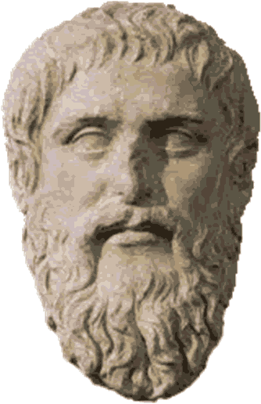
Plato saw his imperfect world and thought of ways he could improve society. Plato wrote about utopia. A utopia is an imaginary place where governments and social conditions are perfect. No government has ever adopted Plato’s ideas, but his philosophy influenced leaders for over two thousand years.
Plato argued in favor of an "aristocracy of merit," or rule by the best and the wisest people. Plato believed that government should raise all children so that everyone would have equal opportunities. Schools would test students on a regular basis. Students who did poorly would be sent to work, while those who did well would continue their studies. Plato believed a small group of intelligent and educated men and women should govern society. This small group would select the best and the brightest students to join them.
Later in his life Plato mentored a young man named Aristotle. A mentor is someone who teaches or gives help and advice to a less experienced and often younger person. Aristotle’s ideas would form the basis of modern science.

Fill in the Blanks
Plato was a p__i__o__o__h__r who studied with S__c__a__es. A d__c__de after Socrates’ d__a__h, Plato used his family’s *w__a__th to open a school called the A__a__e__y. Plato tried to imagine a perfect world called a u__o__ia. In Plato’s utopia all c__i__d__en had equal o__p__r__u__i__y because the children would be r__i__ed by the g__v__r__m__nt. Plato imagined a world governed by its most i__t__l__i__e__t citizens. No government has adopted Plato’s ideas of a utopia, but his philosophy i__f__u__n__ed leaders for over two *m__l__e__n__a. Late in life, Plato m__n__o__ed a young man named A__i__t__t__e. Aristotle’s ideas would form the b__s__s of modern s__i__n__e.

Answer in complete sentences
1. Do you agree or disagree with Plato’s idea of a utopia? Explain your reasoning.
*2. What is a mentor? Who is your mentor? Explain your reasoning.

