THE BYZANTINE EMPIRE

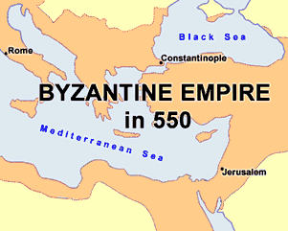
By 285, the Roman Empire had become too big for one ruler to manage. Conflicts among the many cultures of the empire developed into several wars, so Emperor Diocletian appointed a sub-emperor, called a Caesar, to rule the western half of the empire.
Diocletian ruled the eastern half, an indication that the East was the richer, more stable portion of the empire. While the West was prone to frequent attacks from barbarian tribes and relied heavily on agriculture, the Eastern Empire was more secure and had a varied economy.
In 330, Constantine moved his capital from Rome to the Greek-speaking city of Byzantium. He named the city Constantinople, which means “Constantine’s city.” Constantine wanted his capital to be safe from barbarian invasion, so he chose a location at the end of a high peninsula that is surrounded by water on three sides.
Constantinople was located on the Bosporus Strait, a narrow waterway that connects the Black Sea to the Mediterranean Sea. This location made the city a center of trade, and people from faraway lands traveled to Constantinople to conduct business, making it one of the most world’s most important cities.
The emperors who followed Constantine considered themselves to be Roman. Modern scholars describe the eastern empire as the Byzantine Empire particularly after the fall of Rome in 476. Byzantine refers to the original name of Constantine’s capital, Byzantium.
In 800, Pope Leo I crowned Charlemagne Holy Roman Emperor. Byzantine leaders considered Charlemagne’s coronation an insult; they considered themselves to be the rulers of both Christendom and the Roman Empire. The disagreements between east and west continued for centuries leading to a schism, or separation of the church. After 1054, many Eastern Orthodox Churches no longer acknowledged the Pope, while the Western Roman Catholic Church accepted the Pope as the leader of their faith.
The Byzantine Empire began to look less like the Roman Empire as the years passed. The empire covered present-day Greece, the Balkans, Asia Minor, Syria, and Egypt. By the seventh century, Greek had completely replaced Latin as the language of the Empire.
In the middle of the 11th century, the borders of the Byzantine Empire began to be overrun by Turks. The Turks had recently converted to Islam, and the Byzantine emperor feared the Muslims would soon overpower his Christian empire. The emperor asked the Pope— the leader of the Western Christian church—to assist in a holy war against the Turks.
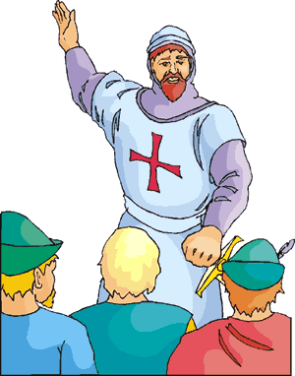
In 1095, Pope Urban II launched the first of many Crusades, or “wars of the cross.” Urban hoped that in addition to expelling the Turks from the Byzantine Empire, he would also be able to reclaim the holy city of Jerusalem from Muslim control. Soldiers from throughout Western Europe left their homes to free the Byzantine Empire of the “unbelievers.” Their exposure to new and different cultures was a factor that would eventually lead to the Renaissance hundreds of year later.
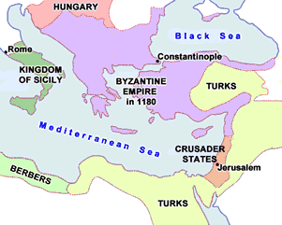
Christian warriors captured Jerusalem in 1099, but a Kurdish warrior named Saladin reclaimed the land for Islam in 1187. Crusaders continued for fight nearly two hundred years, and ultimately the Christian warriors were unsuccessful.
The Turkish Ottoman Empire eventually conquered most Byzantine land. Constantinople fell to the Turks in 1453. The Turks called the city Istanbul, a word that means “the marketplace,” but the Turkish government did not make the change official until 1930. Turkish has replaced Greek as the language of Asia Minor, and today, more than 99% of the people in modern Turkey are Muslims.

Fill in the Blanks
The Roman Empire was divided in two by Emperor D__o__l__t__an in 285 because it had become too big for one person to manage. Diocletian chose to rule the E__s__e__n Empire himself because it was less p____e to a__ta__k and from outsiders had a more varied e__o__o__y than the Western Empire. E__p__r__r Constantine later moved the c__p__t__l of the empire from Rome to the G__e__k city of B__z__n__i__m.
The Byzantine Empire covered present-day G__e__ce, the B__l__an Mountains, Asia Minor (now *T__r__ey), S__r__a, and E__y__t. By the seventh century, Greek had replaced L__t__n as the primary l__n__u__ge of the B__z__n__i__e Empire.
In the eleventh century, the Byzantine Emperor feared the influx of M__s__im Turks would overpower his C__r__s__i__n Empire, so he called upon the head of the W__s__e__n Church to assist in a h______ war against the Turks. Pope U__b__n II called for the first of several C__u__a__es, or “wars of the cross.” C__r__s__i__n warriors captured their holy city of J__r__s__l__m, but a M__sl__m army led by S__l__d__n recaptured the city in 1187.
The Turkish O__t__m__n Empire eventually captured most B__z__n__i__e land. Today, the city that was once Byzantium and C__n__t__n__i__o__le is now known as I__t__n__ul, Turkey.

Answer in Complete Sentences
1. Why did Constantine move his capital from Rome to Byzantium?
*2. Why do modern scholars refer to the Eastern Roman Empire as the Byzantine Empire?
*3. Why were Byzantine rulers unhappy with Charlemagne’s coronation as Holy Roman Emperor?
4. How does the Eastern Orthodox Church differ from the Western Roman Catholic Church?

