The Renaissance Spreads

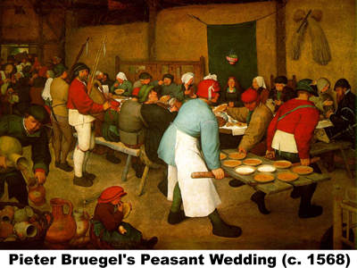
The rebirth of the Italian cities attracted visitors from all over western Europe. Merchants and bankers hoped to make their fortunes in the Italian city-states. Artists and students sought knowledge and fame. When these travelers returned home, they brought Renaissance ideas with them. In time, the ideas of the Renaissance influenced people far from the Italian peninsula.
Italian Renaissance painters often focused on religious subjects, but the art of the low countries of northwest Europe was more concerned with portraits, landscapes, and scenes of everyday life. This was partly because most people of the low countries were Calvinists—a branch of Christianity that believes in building simple churches without ornamentation.
Pieter Bruegel the Elder (1525 –1569) was from Flanders. Flanders is a Dutch speaking land that is now part of Belgium. Bruegel studied Italian art, but he developed a different style. He wanted to show people as they actually lived. Many of his paintings show peasants working, dancing, and eating.
England’s William Shakespeare (1564 – 1616) is the best-known writer of the Renaissance. His plays mixed humor with drama and showed the strengths and weaknesses of people. Audiences flocked to see his presentations of Roman emperors, British kings and queens, and Italian teenagers.

Answer in Complete Sentences
1. How did the ideas of the Renaissance travel far from the Italian peninsula?
*2. How were Pieter Bruegel’s paintings different from the Italian paintings?
3. Why was William Shakespeare the best-known writer of the Renaissance?

