Name:
Date:
THE CONFLICT WIDENS

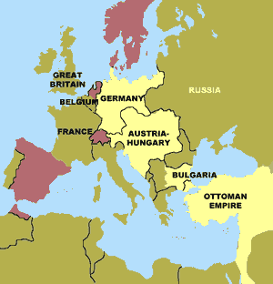
After the death of Francis Ferdinand in 1914, Austria-Hungary declared war in July. Their close ally, Germany, joined the fight a month later. By November, they were joined by the weakened Ottoman Empire.
Present-day Turkey is a remnant of the Ottoman Empire. In the nineteenth century, the Ottoman Empire extended from Algeria in the west to Mesopotamia in the east. But by the eve of World War I, the empire had lost territory, and Ottoman control over other regions was weak. In fact, writers of the time called the Ottoman Empire "the sick man of Europe.” By beginning of the twentieth century, many people believed that it was only a matter of time before one of the European colonial powers conquered part or all of the six hundred-year-old Ottoman Empire.
A group of military officers known as the Young Turks had seized control of the Ottoman Empire in a 1908 revolution. The Young Turks decided to join the Great War on the side of the Central Powers when it seemed that Germany would win the conflict. The Turks feared two of the Allied Powers. Russia was north of Turkey and wanted access to what the Russians called a “warm water port.” The Russians had no direct access to the sea trade in the Black Sea and the Mediterranean Sea. All of Russia’s other ports at that time froze during the winter months. The Young Turks feared if they did not enter the war, Russia would conquer part of Turkey to gain access to the Black Sea.
The Young Turks were also convinced that a victory against Russia would allow the empire to regain land lost to Russia in Central Asia. At the beginning of World War I, Great Britain’s empire included India, east of Mesopotamia. The Young Turks believed that their needs would be best met by joining forces against these two rivals.
The Ottoman Empire signed a treaty with Germany in August 1914 and, within weeks, sent troops into battle. The following year, Bulgaria also joined the war on the side of the Central Powers in hopes of gaining land from Serbia once the Allies were defeated.
At the beginning of the Great War, many observers believed this alliance to be the strongest in history. As it turned out, another coalition of nations would outlast the Central Powers.

Answer in complete sentences
1. Why was the Ottoman Empire known as the “Sick Man of Europe” in the years leading up to the Great War?
*2. What is a “warm water port?” Why would Russia be very interested in having a warm water port?
3. Why were the Turks fearful that Britain would expand its empire into Turkish holdings?

