Name:
Date:
THE GREAT WAR

Both the Allied Forces and the Central Powers expected the conflict that became World War I to end quickly. Neither side understood how technology made a long, terrible war possible. Prior to the nineteenth century, most guns shot a single load. The invention of the machine gun and rapid-fire artillery made warfare more deadly. Consequently, both sides were forced to defend their territory by fighting from deep trenches.
The trenches were terrifying. Machine gun fire erupted whenever a soldier allowed his head or weapon to appear above the trench. Even more frightening were the large artillery guns that launched shells from behind the trenches. One soldier described the shelling as being inside a thunderclap. He said it was the only noise you felt with your entire body. The soldiers had more to fear than bullets and shells. The Great War marked the beginning of the use of chemical weapons. Tear gas caused blindness, while chlorine gas suffocated the soldiers. Mustard gas was an oily, sticky substance that left its victims blinded, blistered, and struggling for every breath.
Heavy rain was an additional hazard in the trenches. Thousands of soldiers drowned; many more were wounded as they fell in the mud. It was not uncommon for a soldier to stand many days in parasite-filled water as high as his chest. One result of this was a disease called trench foot. Many soldiers had to have their feet or legs amputated because of standing in the water-filled trenches.
In pervious wars, soldiers met on a battlefield and carried off their dead after the fighting ended, but trench warfare in the Great War was different. Wounded soldiers often could not be rescued. Dead bodies from both sides of the conflict became part of the landscape. The decomposing bodies attracted rats, which sometimes grew to the size of small dogs. Soldiers were often afraid to sleep at night, fearing an attack of rats. As one soldier said, “If ever there is a true hell on earth, it is here in the trenches.”
High above the trenches another even more deadly war took place in the skies. The airplane was another new addition to warfare. The average life expectancy of a new pilot was between three and six weeks, but American recruiters managed to build an air force of more than 200,000 men.
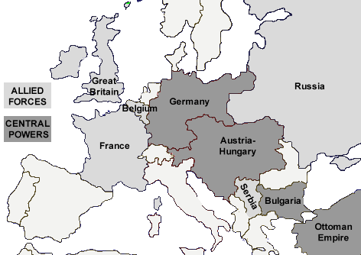
There were several reasons why many young men risked their lives as pilots in the Great War. The pilots had more control over their lives than regular soldiers. A soldier in the trenches might be killed by a bullet or shell without warning, but an agile flying “ace” might have a good chance of staying alive if he was careful. Air battles were quick and decisive, unlike life in the muddy trenches. After their missions, they returned to their air bases far from the enemy lines. As one American soldier wrote from the trenches, “The glamour boys are sleeping on real beds with pillows and sheets, while we wallow in the lice and vermin. I don’t begrudge them their due—I’m simply jealous as hell.”
Worst of all, the conflict that most Europeans thought would be brief turned into a deadly world war that dragged on longer anyone expected.

Name:
Date:

Fill in the Blanks

T__c__n__l__g__c__l advances made war more deadly in the t________________ century. The i_______________ of the m____________ gun and rapid-fire a________________ forced armies to fight from deep t______________ dug into the e________. Thousands of s______________ drowned in the m________ trenches. Others died from *d______________ such as trench foot. Soldiers in the t______________ also had to fear c______________ weapons such as m____________ gas.

The battlefield moved to the s____ in the Great War. A p__l__t was far more likely to be k__________ than a s____________, but there was never a *s______________ of *v__l__n__e__rs to join the *a____ war. A pilot controlled his destiny in q________ and d______________ battles, while the s______________ below faced a horrendous existence among the lice and vermin in the m________ trenches.

Answer in complete sentences
*1. Why were the armies fighting in the Great War forced to dig trenches instead of fighting on a battlefield?
*2. Write a paragraph that explains why many young men risked their lives as pilots in the Great War.
*3. Many of the soldiers left young families behind. If you could make a choice, would you have chosen to be a soldier or a pilot? Would your family want you to make the same choice? Defend both decisions.

