Name:
Date:
New Opportunities for African Americans

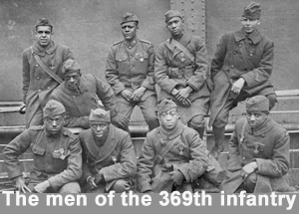
When the United States entered World War I, most black Americans lived on farms in the south. They were technically “freed” after the Civil War, but most black Americans lived in extreme poverty. There were better paying jobs in factories and railroads in the North, but those jobs were usually filled by European immigrants.
The flood of immigrants stopped when war broke out. The factory jobs they usually filled were now open to black workers. By 1920, more than 350,000 black people moved to the North. They settled in railroad and industrial centers such as New York, Boston, Chicago, Detroit, St. Louis, and Cleveland.
White farmers and business owners in the South depended on black workers to fill low paying jobs. Communities in Georgia and Mississippi passed laws limiting the number of black people who could ride trains. The mayor of New Orleans made a formal request to the president of the Illinois Central Railroad to stop all northbound trains carrying black passengers.

The black people found jobs in the North, but they also found resentment and prejudice. Almost all unions were closed to blacks. In some cases, the resentment erupted into violence.
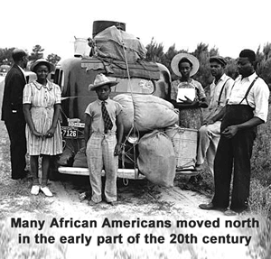
Black men did serve in the American army, but most were only allowed to work in menial jobs. They worked as kitchen staff or dockworkers. There were three all-black divisions who fought at the front, but white officers commanded those divisions. The American army did not integrate until after the Second World War.

Two Perspectives
Many Black American leaders opposed participation in the Great War. A. Philip Randolph argued that Black Americans should not participate because they were denied “full citizenship.” W.E.B. DuBois disagreed, arguing, “while the war lasts [we should] forget our special grievances and close our ranks shoulder to shoulder with our white fellow citizens and allied nations that are fighting for democracy."

Name:
Date:

Fill in the Blanks

The outbreak of the Great War caused a great *m__g__a__i__n of b________ Americans from the *r__r__l South to c__________ in the North. F____________ jobs were usually filled by i________________ from E__________, but the w____ temporarily stopped the flood of immigration, and created o_______________________ for b________ people. Many farmers and businesspeople in the South d______________ on black w____________ to fill l____ paying jobs. There were many *a______________ to keep Black A_______________ in the S________. Those B________ Americans who did reach the North found j______, but they also found *b__g__t__y. They were barred from joining most u__________, and often faced v______________ from other *w____________.

Answer in complete sentences
1. Why did many Black Americans leave their homes in the rural South when the Great War broke out?
2. Why did A. Phillip Randolph oppose participation by Black Americans in the Great War?
*3. Why did W.E.B. DuBois argue that Black Americans should “close ranks” with their “white fellow citizens” during the Great War?
*4. Describe the roles of Black service members of the American army in the Great War.

