Name:
Date:
A SEPARATE PEACE

The German army fought the Great War on two fronts. They battled the French, British and Belgians on the Western Front, while they faced Russia on the Eastern Front. By 1917, the Russians were too busy solving their own problems to continue fighting in the Great War.
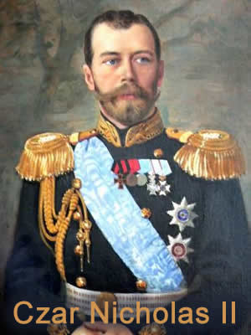
Russia had two civil wars in 1917. Russia was led by a czar (often spelled tsar), a word that derives from Caesar. The Russian Czars saw themselves as modern day Caesars, and they ruled their nation with little regard for the Russian people. Living conditions were harsh for many Russians during the Great War. The war had continued longer than planned and the Russian people were expected to work in dirty factories with little food to support the war effort. Food shortages caused by the war led to public unrest. Workers went on strike and riots became common in Russian cities. Czar Nicholas II was forced to abdicate, or leave power, in March, 1917. A weak provisional government formed, but within months, a second revolution brought the Bolsheviks to power. The Bolsheviks were followers of Karl Marx, a nineteenth century German writer who called for a worker’s revolution. Radical forces led by Vladimir Lenin toppled the provisional government and established a Marxist government in Russia.
The Bolsheviks had no interest in continuing the war. In March, 1918, the Russians agreed to the Treaty of Brest-Litovsk. This “separate peace” with Germany had harsh terms. Russia left the war, but it was forced to turn over Finland, the Baltic provinces, parts of Poland and Ukraine to the Central Powers. Germany could now move all of its soldiers to the Western Front, just in time to face a new opponent.

Fill in the Blanks
Russia was the f________ nation to l________ the G________ War. Two c________ wars in 19____ forced the R____________ people to focus on internal problems. Russia agreed to a “s______________ peace” with Germany in 1918. R__________’s new g__________________ lost a great deal of l______ in the *p________ agreement. The “separate p________” allowed G____________ to move *s______________ to their w____________ front in time to face fresh troops arriving from *A____________.

Answer in complete sentences
1. Why did Russia leave the Great War?
2. Who were the Bolsheviks?

