The Aztecs

When the Spanish conquistadors arrived in Mesoamerica, they learned of the rich and mighty Aztecs, the most powerful civilization in the New World. The Aztec capital was Tenochtitlan (pronounced te-noch-tit-lan), a city of more than 200,000 people filled with gold and silver.
At the center of Tenochtitlan stood a towering pyramid topped by temples for the Aztec gods of the sun and the rain. Palaces for wealthy Aztec nobles surrounded the pyramids. Their great wealth and power obscured the fact that the Aztec hid even from themselves: not long before, they were a desperately poor nomadic people who wandered onto the land that would become their home in the Valley of Mexico.
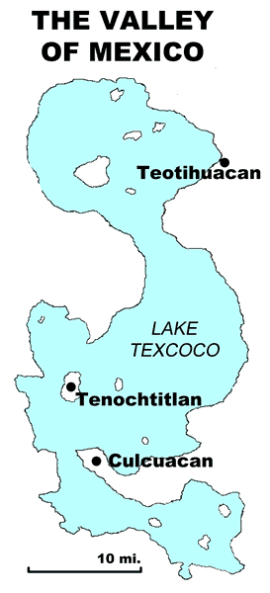
The Aztecs trace their history to Aztlán (pronounced ahz-LAHN), an area north of the Valley of Mexico, perhaps in what is now the southwestern United States. The Aztecs called themselves the Mexica (pronounced ma-SHEE-ka), a name from which Mexico is derived. The term Aztec means “person of Aztlán.” It was first used in the nineteenth century to distinguish the modern people of Mexico from the ancient civilization.
When the Aztecs arrived in the Valley of Mexico about 1300, their neighbors scorned them. The people of the valley considered themselves to be the proud descendants of the Toltec people, while they viewed the Aztecs as savage, uncivilized drifters.
The Aztecs wandered around the valley until the King of Culhuacan (pronounced kool-wha-kan) allowed the Aztecs a permanent home in exchange for working as mercenaries. Mercenaries are soldiers hired to fight for a living. The Aztecs also worked at lowly jobs that other people rejected. As time passed, the Culhuacan people began to respect the hard work and brutal fighting skills of the Aztecs.
In 1323, the King offered his daughter in marriage to the Aztecs, thereby inviting them into his royal family. The Aztecs sacrificed the Culhuacan princess to Huitzilopochtli (pronounced wete-see-o-POK-ta-lee), their bloodthirsty god of war. The enraged king expelled the Aztecs, forcing them once again to wander the Valley of Mexico.
The Aztecs lived in a land of earthquakes that caused great destruction. Their legends said the gods destroyed and recreated the world over and over. They believed that the world would be destroyed once again if they did not satisfy their gods by providing them with human sacrifices.
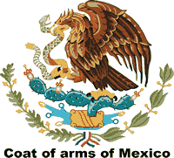
An Aztec priest had a vision that they should build their new home at a place where they found an eagle sitting on a cactus with a snake in its mouth. After two years of wandering, the Aztecs found that unique vision on a small island in the middle of Lake Texcoco, so they waded into the shallow lake to build their new home. The image of the eagle, cactus, and snake are part of the flag of present-day Mexico.
The Aztecs created farmland in their new home by constructing a series of artificial islands called chinampas. They marked off small areas with poles and clay walls, then filled the space with muck taken from other parts of the lake, leaving enough room for canoes to travel between the islands. The surfaces of the chinampas were fertile land that provided the Aztecs with as many as seven harvests a year.
In 1427, the Aztecs formed a secret agreement with two other kingdoms. This Triple Alliance conquered the other cultures of the valley and forced them to pay tribute, or payment for protection.
When they gained control of the Valley of Mexico, the Aztecs rewrote history to hide their humble origins. Tlacaelel (pronounced tlak-ah-lel) was the half-brother and closest advisor of Aztec King Moctezuma I. Tlacaelel ordered all old history books burned so there would be no memory of who the Aztecs once were. Tlacaelel’s new history said Huitzilopochtli chose the Aztecs to rule the valley. By erasing history, the Aztecs made their transformation complete. They had gone from peasants to princes.

Fill in the Blanks
When the Spanish *c__n__u__s__a__o__s arrived in the Americas in the *s__x__e__n__h century, the Aztecs were the most r__c__e__t and most powerful *n__ti__e civilization. But little more than 100 years earlier, they were poor n__m__ds who wandered the C__n__r__l Valley of M__x__co in search of a home. The Aztecs trace their history to a place they called A__t__án, which might be in the s__u__h__e__t__rn United States. When the Aztecs first arrived in the valley, they were scorned by the other cultures as s__va__e and u__c__v__l__z__d drifters. The Aztecs were fierce warriors, so they soon found work as m__r__e__a__i__s working for the King of Culcuacan. The king e__p__l__ed the Aztecs after they s__c__i__i__ed the King’s d__u__h__er to the Aztec’s w___ g___, Huitzilopochtli.
After their expulsion, the Aztecs created a homeland on a small i__l__nd in Lake T__x__o__o. They expanded their territory by constructing several a__t__f__c__al islands called c__i__a__p__s. The chinampas provided the Aztecs with *f__r__i__e land that allowed their *p__p__l__t__on to grow.
Answer in Complete Sentences

*1. What did the Aztecs call themselves? Why do we refer to them as Aztecs?
- What is the meaning of the eagle, cactus, and snake on the flag of Mexico?
3. What were chinampas?
- What was the Triple Alliance?
- Why did Tlacaelel rewrite Aztec history?
*A higher order-learning question. Any reasonable answer will be accepted.

The

