The First Americans

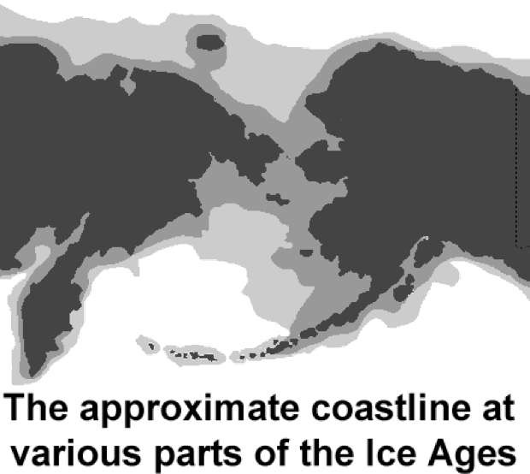
Over thousands of years, people spread out from Africa into Europe and Asia. Long before the invention of farming, the wheel or writing, the first hunters reached Beringia. Beringia is a modern name for a strip of land that once connected Asia to Alaska in North America.
The current evidence suggests the first humans crossed this “land bridge” at least 40,000 years ago and perhaps even earlier.
Asia and America have been separated by the Bering Strait for about 15,000 years. The continents are now more than fifty miles apart, but at one time they were connected by a passage more than 1000 miles wide.
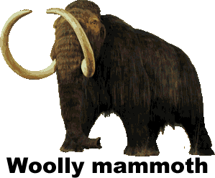
Beringia existed during the Ice Ages, periods when the climate of the earth was colder. During an Ice Age, precipitation that fell on land would harden into large masses of ice called glaciers. The forming of glaciers caused sea levels to fall about three hundred feet.
Scientists fear modern industry has made the earth warmer, causing ice at the Polar Regions to melt. These melting ice caps could cause the oceans to rise and coastal lands to be submerged.
Although the climate of Beringia was very cold, it appears to have been warmer than nearby land is today. Beringia was not covered with ice because there was very little snowfall in the region. Instead, Beringia was covered with grass and small trees that fed large mammals such as bears, bison and the now extinct woolly mammoths and mastodons. These animals attracted human hunters to the region. The hunters who crossed Beringia into America came in small groups beginning about 40,000 years ago.
As the earth grew warmer, the glaciers melted and the land bridge slowly closed about 15,000 years ago—this was at least 9000 years before civilizations developed in Egypt, Mesopotamia, and China. Today more than 50 miles of ocean separates Asia from North America.
The Inuit—traditionally known by outsiders as Eskimos—also reached America from Asia, but long after the land bridge had closed. The Inuit crossed the frigid waters of the Bering Strait in boats between 6000 and 2000bce. Their DNA indicates that the Inuit are genetically unrelated to the other indigenous people of America.
Archaeologists are also intrigued with ancient skeletal remains found primarily in South America that do not fit the profile of the people who passed through Beringia. DNA evidence suggests that there may have been some migration to America from the Polynesian Islands of the Pacific, possibly by sailors who were blown off course.
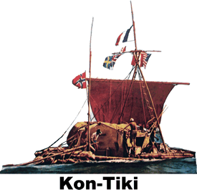
In 1947, adventurer Thor Heyerdahl constructed a raft using ancient technology. Heyerdahl and a crew of six sailed 3770 miles on the Kon-Tiki, named for an Inca god. Their 97-day journey took them from Peru to the island of Puka Puka. Heyerdahl’s voyage proved that it was possible for ancient sailors to travel the Pacific Ocean, but not that it actually occurred.

Fill in the Blanks
About ____,000 years ago, the first humans crossed a land bridge from A__ia to the A__e__i__as. They were probably h__n__e__s in search of large mammals that included b__s__n and m__s__a__o__s. The l____d b__i__ge between Asia and the Americas closed about ____,000 years ago as g__a__e__s melted and sea l__v__ls rose about ______ feet. The c__o__i__g of the land bridge occurred t__o__s__n__s of years before c__v__l__z__t__on developed in M__s__p__t__m__a, Egypt, and C__i__a.
The Inuit crossed the B__r__ng S__r__it from Asia long after the c__o__i__g of the land bridge, but thousands of years before the arrival of the E__r__p__a__s. There is also evidence that *s__i__o__s reached the Americas from the P__l__n__s__an Islands of the P__c__f__c. Adventurer Thor H__y__r__a__l proved that it was p__s__i__le for an a__c__e__t ship to travel between Polynesia and America, but we know know why or when any sailors from the Pacific arrived in America.
Answer in complete sentences
*1. Explain why there are no written records from Beringia.
*2. Why did the sea level rise at the end of the ice age.
*3. Explain why are many modern scientists concerned about global warming.
4. How do the Inuit differ from most other indiginous people of the Americas?
5. What did Thor Heyerdahl’s expedition prove?
*This is a higher order-learning question. Any reasonable answer will be graded as correct.

