The New World

When Christopher Columbus arrived in the Caribbean Sea in 1492, he called the people he encountered “Indios,” because the mariner was convinced that he had sailed to one of the islands of Southeast Asia—land many Europeans called the Indies. Although Columbus likely died believing he reached Asia, we know today that he stumbled on what his fellow Europeans would eventually call a New World.
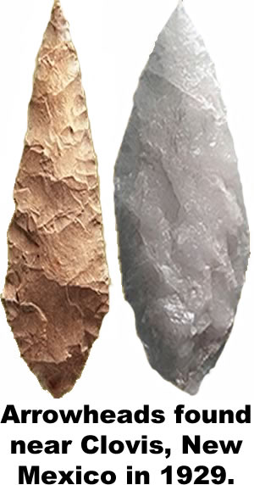
Through trade routes or war, the people of the Old World—Europe, Asia, and Africa—had been trading goods, ideas, and even diseases for thousands of years before the Colombian voyage. But far from the influences of the Old World, the people of the Americas had developed their own unique cultures.
The oldest agreed upon evidence of advanced civilization in the Americas comes from 13,500 year-old spear points found near Clovis, New Mexico. By 10,000 years ago—long before civilizations in Mesopotamia, Egypt, and China flourished, humans occupied every section of North and South America from modern Alaska to the Caribbean Islands and the southern tip of South America.
As people spread across the continents, they began to speak different languages and develop distinct cultural traditions. By the time Columbus arrived, the population of the New World was estimated to be between 50 and 75 million—though there is some evidence that as many as 100 million people lived in the Americas in 1492. The indigenous peoples of the New World included about 350 major ethnic groups who spoke over 160 distinct languages.
Their societies ranged from simple to sophisticated. The Maya, the Incas, and the Aztecs developed complex architecture that required great mathematical skill to construct, though even today, the Yanomami people of Brazil and Venezuela live a lifestyle similar to that of nomads thousands of years ago.
It was a world without the wheel as a method of transportation. The most advanced cultures of the New World lived on mountainous land where the wheel would be of little value. Native Americans occasionally used wheels on children’s toys—but they saw no value in using the wheel as a tool for adults.
Additionally, there were few animals in the New World large enough to drive a plow. The Native Americans hunted several large mammals to extinction thousands of years before the arrival of the Europeans. The remaining large mammal—the bear—could not be domesticated. The people who lived high in the Andes often used llamas to carry goods, but llamas are unpredictable and generally not strong enough to support the weight of an adult man.
The people of the Old World often lived close to their domesticated animals—often sheltering livestock inside their homes. Smallpox, measles, influenza, and other illnesses developed first in animals and eventually evolved into strains that were deadly to humans. The close contact with animals allowed the people of the Old World to develop some resistance, or immunity to these diseases. While it was common for many people of the Old World to die of epidemics, the diseases would not often destroy entire populations.
The people of the Americas, however, had not been exposed to Old World illnesses. In 1492, the population of the Americas outnumbered that of Europe, but within a generation, diseases spread across the New World, killing an estimated 95 percent of the indigenous people.
The Old World’s greatest weapon in their quest to conquer America was disease, a weapon they did not know they had.

Fill in the Blanks
The peoples of Europe, Asia, and Africa has been __a__i__g goods, i__e__s, and d__s__a__es for thousands of years through t__a__e and w__r. But when C__r__s__o__h__r C__l__m__us sailed to America in 14____, he unwittingly discovered cultures that had developed apart from the O__d W__r__d. The Native Americans Columbus encountered included 3____ major ethnic groups that spoke over 1____ distinct languages.
The Europeans carried diseases such as s__a__l__ox, influenza, and m__a__l__s to America. The idigenous people had not been e__p__s__d to those d__s__a__es, so their i__mu__e systems were not p__e__a__ed for their introduction. As a result, approximately *n__n__t__en out of twenty Native Americans fell *v__ct__m to d__s__a__e in the years following their first *e__c__u__t__r with E__r__p__a__s.
Answer in complete sentences
1. Why did Christopher Columbus call the people he encountered in America “indios?”
2. What was significant about what archaeologists found near Clovis, New Mexico?
*3. Write a paragraph that explains why the indigenous people of the Americas did not use the wheel as a tool. Your answer must include a topic sentence, at least two support sentences, and a conclusion that restates but does not repeat the topic sentence.
4. Explain the primary reason why historians believe most Native Americans died after 1492?
*This is a higher order-learning question. Any reasonable answer will be graded as correct.

