Rediscovering the Maya

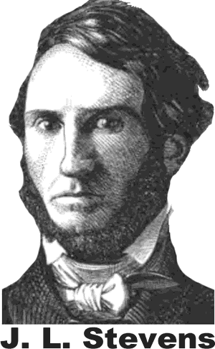
John Lloyd Stevens was an American lawyer and diplomat, but his passion was travel and exploration. While in London in 1836, Stevens met an artist named Frederick Catherwood, who shared his dream of exploring the uncharted land of Mesoamerica. Three years later, American President Martin Van Buren commissioned Stevens to be his ambassador to the region.
While in Mesoamerica, the two men made amazing discoveries. Stevens’ writing and Catherwood’s drawings also introduced many people of the nineteenth century to the Maya civilization for the first time.
The men learned of a wall of stone partially buried in the shrubs and trees of the jungle in the Yucatan Peninsula. They had encountered the remains of a temple in Copan, a city abandoned one thousand years earlier by the Maya. The Maya were an advanced civilization that flourished in Mesoamerica for more than a millennium. Hoping to dismantle the site and sell it to American museums, Stevens is said to have purchased all of Copan for fifty dollars.
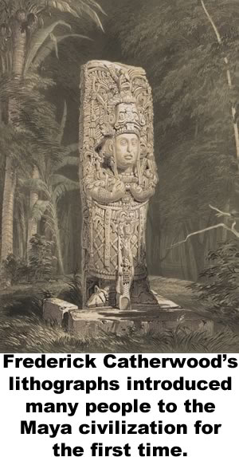
In the middle of the nineteenth century, most people were aware of the great civilization created further to the north by the Aztecs in central Mexico, and the civilization of the Incas, high in the Andes Mountains of South America. The Maya, however, were all but unknown beyond their native land. There were some fantastic legends known to the modern inhabitants, but no other indications that the poor people who lived in the jungles of Central America were part of one of the most advanced ancient civilizations in history. Stevens and Catherwood eventually discovered the ruins of thirty-six Maya cities including now famous sites at Palenque and Chichén Itzá.
Stevens and Catherwood also encountered many samples of the mysterious writing of the Maya carved in stone. We know now that the Maya were the only Mesoamericans to create a fully complex form of written language. Some Maya glyphs represented objects, like a pictographic language. Others represented sounds. In some cases, a single glyph represented both a sound and an object. Today we can identify more than 2000 Maya glyphs, but Stevens and Catherwood were unable to decipher the stones they discovered.
Maya codices were folding books on cloth made from tree bark. All but a handful were destroyed in 1562 by the order of a Spanish bishop.
Diego deLanda As he later wrote,

“We found a large number of books…and, as they contained nothing in which were not to be seen as superstition and lies of the devil, we burned them all, which they (the Maya) regretted to an amazing degree, and which caused them much affliction.”

Before he did this, however, deLanda recorded his observations of Maya culture and examples of their writing. deLanda’s observations were lost for nearly three hundred years until they were rediscovered in 1862. The bishop’s manuscript was the first key to unlocking the puzzle of the previously unreadable Maya writing.
At least four of the original Maya books, called codices escaped the fire. As scholars learned to decipher the language, the books provided insight to Maya mathematics and astronomy. The codices tell us very little of everyday life for the Maya, and nothing about how the common people of the region lived. There are still many mysteries to discover as archaeologists continue to probe the jungle and find more clues about the Maya people. Researchers speculate that we will know a lot more about the Maya in the years to come.

Fill in the Blanks
Until the middle of the *n__n__t__e__th century little was known of the Maya beyond their n__t__ve land, but the Maya flourished in M__s__a__e__i__a from about 200 to 1200ce. Writer John Lloyd S__e__e__s explored the *r__gi__n in the 1840s with his friend, artist Frederick C__t__e__w__od. The pair discovered the r__i__s of thirty-six Maya sites, including the cities of P__l__n__ue and C__i__hén I__zá. Stevens and Catherwoord encountered Maya writing, but they could not *d__c__p__er its intricate g__y__hs.
The Maya were the only M__s__a__e__i__an culture to devise a complex w__i__t__n language. In addition to what they i__s__r__b__d in stone, the Maya also produced f__l__i__g books called c__d__c__s from tree bark. Diego deLanda, a Christian B__sh__p, destroyed all but a few of the Maya c__d__c__s in 15____ when he realized the Maya were using the books to practice their t__a__i__i__n__l faith. Fortunately, Bishop deLanda r__c__r__ed his o__s__r__a__i__ns of Maya and examples of their writing. What we know will continue to evolve as learn more about the Maya culture.

Answer in Complete Sentences
*1. What is a glyph?
*2. Explain why Maya writing was both phonetic and pictographic. (You may refer to the lesson writing in Mesopotamia for assistance)
3. Why do we currently have only a few Mayan codices?
4. Why do we know very little about the everyday lives of the Maya people?
*A higher order learning question. Any reasonable answer will be accepted.

