Teotihuacan

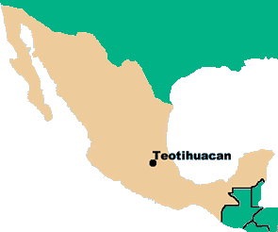
A mysterious city developed in the Central Valley of Mexico about 100bce. It flourished for centuries until it was inexplicably destroyed about 650ce. The city featured two massive pyramids, a magnificent boulevard lined with temples and mansions, and the first apartment buildings in the Americas. Their people also practiced human sacrifice, and their brutal military conquered cultures throughout Mesoamerica.
The truth is that we don’t know what these people called themselves. We call the city Teotihuacan (pronounced tay-oh-tee-wah-KAHN), a term the Aztecs would use when they occupied the site centuries later.
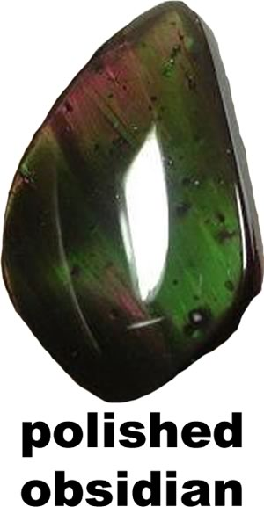
People first settled along the banks of Lake Texcoco in the Valley of Mexico about 300BCE. They farmed the land and mined a stone called obsidian, which they made into jewelry, knives, and other tools. By about 100ce, Teotihuacan developed into a commercial city, home to sculptors, painters and potters.
Two enormous structures, later called the Pyramid of the Sun and the Pyramid of the Moon, dominated Teotihuacan along the Avenue of the Dead. These names reflect the religious beliefs of the Aztecs. We don’t know what the people who built them called the pyramids or the road.
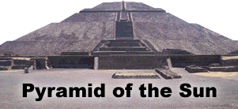
Reaching a height of over two hundred feet, the Pyramid of the Sun is the third largest pyramid in the world. It was constructed about 100CE and expanded about 150 years later. Beneath the base of the pyramid, excavators found a 400-pound statue of Huehueteotl (pronounced we-we-TE-OH-tel), a fire god associated with wisdom. The pyramid was originally constructed over a deep cave. Scholars think the cave may be somehow connected to the ancient civilization’s belief in the underworld, where they believed their gods and ancestors lived.
The Pyramid of the Moon is the burial place of one of the city’s rulers. Smaller than its sister pyramid, it was also the burial place of people and animals that were sacrificed. Most of the walls of the pyramids are only recreations. In the 1880s, excavators used dynamite to explore the pyramids, causing tremendous damage.
The Avenue of the Dead was the city’s main thoroughfare. Smaller temples and homes for the ruling elite of the city lined the boulevard. A grid system of streets radiated from the avenue, creating the first urban infrastructure in the New World and access to housing for Teotihuacan’s workers.
About 250, the city stopped building pyramids and turned its attention to constructing apartment complexes. Excavators have found over 2000 apartment compounds, each housing between fifty and one hundred people. Most apartments were comfortable homes for tradespeople.
The city slowly began to decline in influence in the mid-400s. About 650, it was mysteriously abandoned and burned. Perhaps Teotihuacan was invaded, or its citizens may have faced a natural disaster such as an earthquake or a drought. Centuries later, the Aztecs settled along the lake and were so impressed by its pyramids that they named it Teotihuacan, or “city of the gods.”

Fill in the Blanks
Teotihuacan was a city that f__o__r__s__ed in the Central V__ll__y of Me__i__o for about *______ years until it *m__s__e__i__u__ly vanished about 650. People first settled in the area to f____m and to mine a stone called o__s__d__an. The people used obsidian to create j__w__l__y, knives, and other tools. A c__m__e__c__al city developed by about 100bce, home to s__u__p__o__s, painters, and p__t__e__s.
Teotihuacan featured the P__r__m__d of the S__ and the Pyramid of the M____n along a magnificent boulevard later called the A__e__ue of the D____d. These names were applied by the A__te__s, a civilization that settled in the valley *c__n__u__i__s later. Excavators also found over 250 a__a__t__e__t compounds among the ruins of T__o__i__u__c__n. The apartments served as c__m__o__t__b__e homes for the t__a__e__p__o__le of the city.
Teotihuacan began to d__c__i__e in the mid-400s, but we don’t know why. When the Aztecs arrived in the v__ll__y centuries later, the site was in r__i__s. Today, Teotihuacan is one of M__x__co’s primary t__u__i__t attractions.
Answer in complete sentences

1. Why did the people of Teotihuacan first settle in the Central Valley of Mexico?
*2. Why do we now know what the people of Teotihuacan called their city?
3. Why do scholars believe the Pyramid of the Sun was constructed over a cave?
*4. Copy the sentence in the text tells implies but does not state that the people of Teotihuacan practiced human sacrifice.
5. What might have caused Teotihuacan to decline and fall?
*A higher-order learning question. Any reasonable answer will be accepted.

©2017, Mike Dowling. All rights reserved.

